_model2 tolerance analysis
Document number | TA-MODEL2-001 | Version | V1.0
Organization | Engineering | Classification | Internal
Author | SuperNX | Date | 2026-10-10

1 Overview (part and method)
Analyzed part: _model2.prt
Structure: 8 bodies → 6 part types (Single part with multiple bodies).
Part summary: A planar triangular linkage on a 200 x 40 mm base plate: link T2 pivots on the base at J1, link T3 rides in a pin-in-slot slider J2 on the base, and the two links are hinged together at the apex by a dumbbell pin T6 (J3).
Interfaces were classified from NX-measured geometry facts plus rendered isolations. Fits are taken from ISO 286-1/-2 (H7/g6 for the two revolute pivots, H8/f7 for the pin-in-slot slider) and un-toleranced dimensions from ISO 2768-1 (class f at 5 mm = +/-0.05, 67 mm = +/-0.15; medium class m as the drawing-wide default). Each PMI key characteristic is rolled up worst-case and RSS from the datum feature to the measured feature, with ISO 286 IT10 (0.070 mm at 15 mm) used only for the explicitly toleranced KC15 bore position. Statistical Cpk/PPM are estimates under stated conventions.
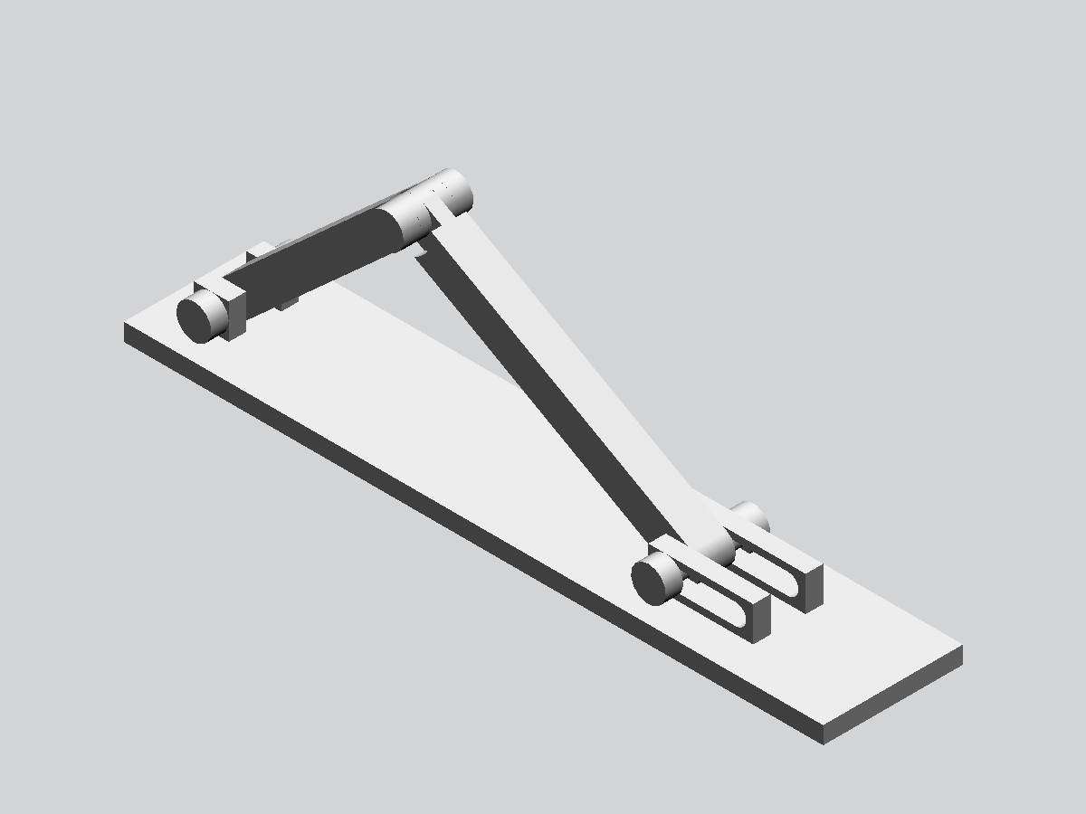
Figure 1-1 Overall 3D view

2 Structure decomposition
Type | Instances | Representative feature | Envelope dimensions (mm) | Interfaces
T1 | ×1 | BLOCK(1) | 200×40×15 | revolute, seat, slider
T2 | ×1 | EXTRUDE(8) | 56.7×52.4×10 | revolute, seat
T3 | ×1 | EXTRUDE(8) | 85.5×53.7×10 | revolute, seat, slider
T4 | ×2 | EXTRUDE(14) | 30×10×0 | revolute, slider
T5 | ×2 | EXTRUDE(15:1B) | 10×10×5 | seat
T6 | ×1 | Pattern Geometry(19:1A) | 20×10×0 | revolute

3 Interface classification
ID | Type | Members (roles) | Geometry | Fit | Evidence (summary)
J1_base_pivot | revolute | T1:bore / T2:bore / T4:pin | Ø6 @[15,20.8,10] Engagement 10 | H7/g6 | Full circles cross-body, 0 mm modeled gap; render shows link T2 eye captured between the two base lugs of T1 on a headed pin T4; the link rotates abo…
J2_slider | slider | T1:slot / T3:bore / T4:pin | Ø6 @[145,20.8,10] Engagement 10 Travel 20 | H8/f7 | Group at x=165 on T1 has only half-circles (8 half, 0 full) spanning 20 mm: open obround slots; render shows pin T4 riding in the T1 slots with the T…
J3_link_pivot | revolute | T2:bore / T3:bore / T6:pin | Ø6 @[65,20,55] Engagement 10 | H7/g6 | 24 full circles cross-body at the link apex (r=3/5/8); render shows two links hinged on the dumbbell pin T6; both links swing (ISO 286 H7/g6)
S1_link_seat | seat | T2:seat / T3:seat | Area 66 | — | Two planar contacts (y=18, y=22) between the links at the apex; axial stacking of the hinge
S2_base_seat | seat | T1:seat / T5:seat | Area 187 | — | Two planar contacts (y=30, x=15 and x=150) between T1 lugs and sheet-body retainers T5 at the pin ends

4 Tolerances by type
Tolerances follow the part's interface constraints; each type has a tolerance card and controlled-feature table.
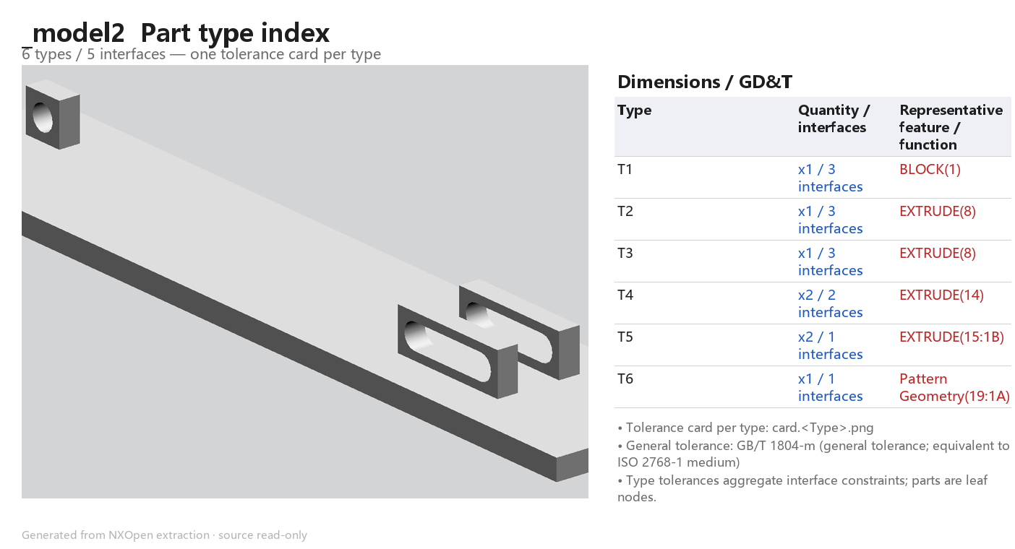
Figure 4-0 Part type index

4.1 T1 (BLOCK(1), ×1)
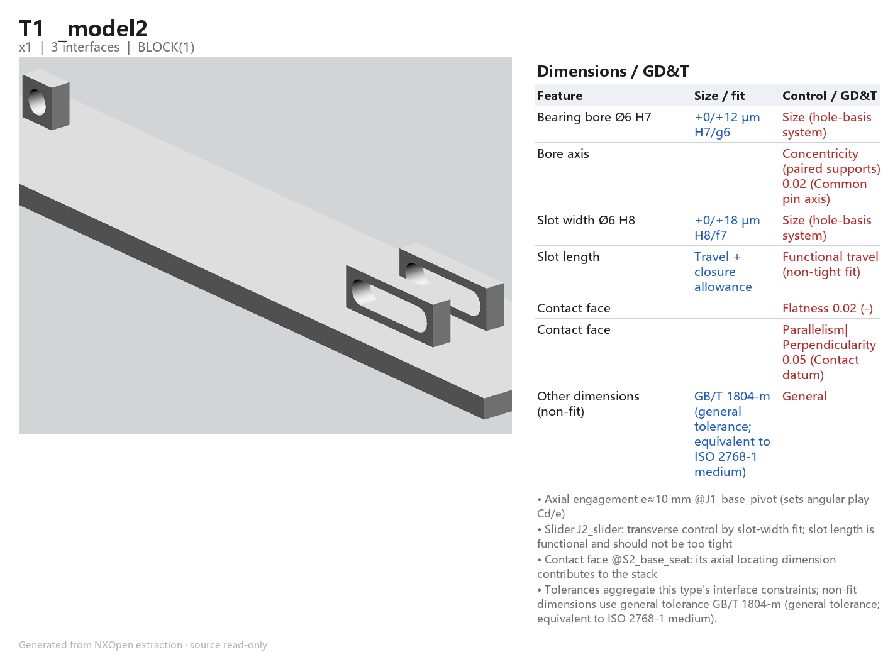
Figure 4-1 T1 Tolerance card
Feature | Size / fit | Control / GD&T | Source interface
Bearing bore Ø6 H7 | +0/+12 µm H7/g6 | Size (hole-basis system) | J1_base_pivot
Bore axis |  | Concentricity (paired supports) 0.02 | J1_base_pivot
Slot width Ø6 H8 | +0/+18 µm H8/f7 | Size (hole-basis system) | J2_slider
Slot length | Travel + closure allowance | Functional travel (non-tight fit) | J2_slider
Contact face |  | Flatness 0.02 | S2_base_seat
Contact face |  | Parallelism|Perpendicularity 0.05 | S2_base_seat
Other non-fit dimensions: ISO 2768-1 class m.

4.2 T2 (EXTRUDE(8), ×1)
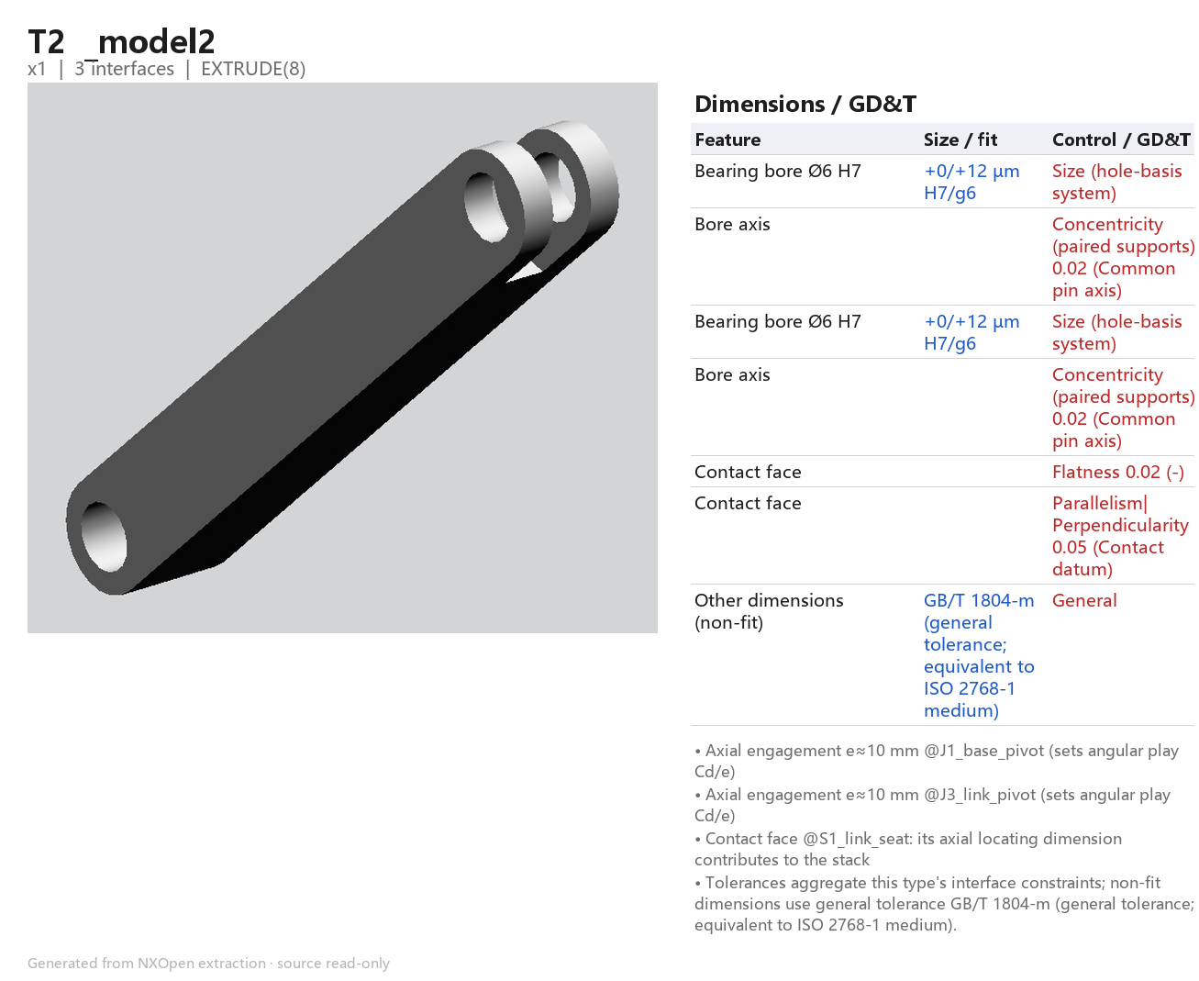
Figure 4-2 T2 Tolerance card
Feature | Size / fit | Control / GD&T | Source interface
Bearing bore Ø6 H7 | +0/+12 µm H7/g6 | Size (hole-basis system) | J1_base_pivot
Bore axis |  | Concentricity (paired supports) 0.02 | J1_base_pivot
Bearing bore Ø6 H7 | +0/+12 µm H7/g6 | Size (hole-basis system) | J3_link_pivot
Bore axis |  | Concentricity (paired supports) 0.02 | J3_link_pivot
Contact face |  | Flatness 0.02 | S1_link_seat
Contact face |  | Parallelism|Perpendicularity 0.05 | S1_link_seat
Other non-fit dimensions: ISO 2768-1 class m.

4.3 T3 (EXTRUDE(8), ×1)
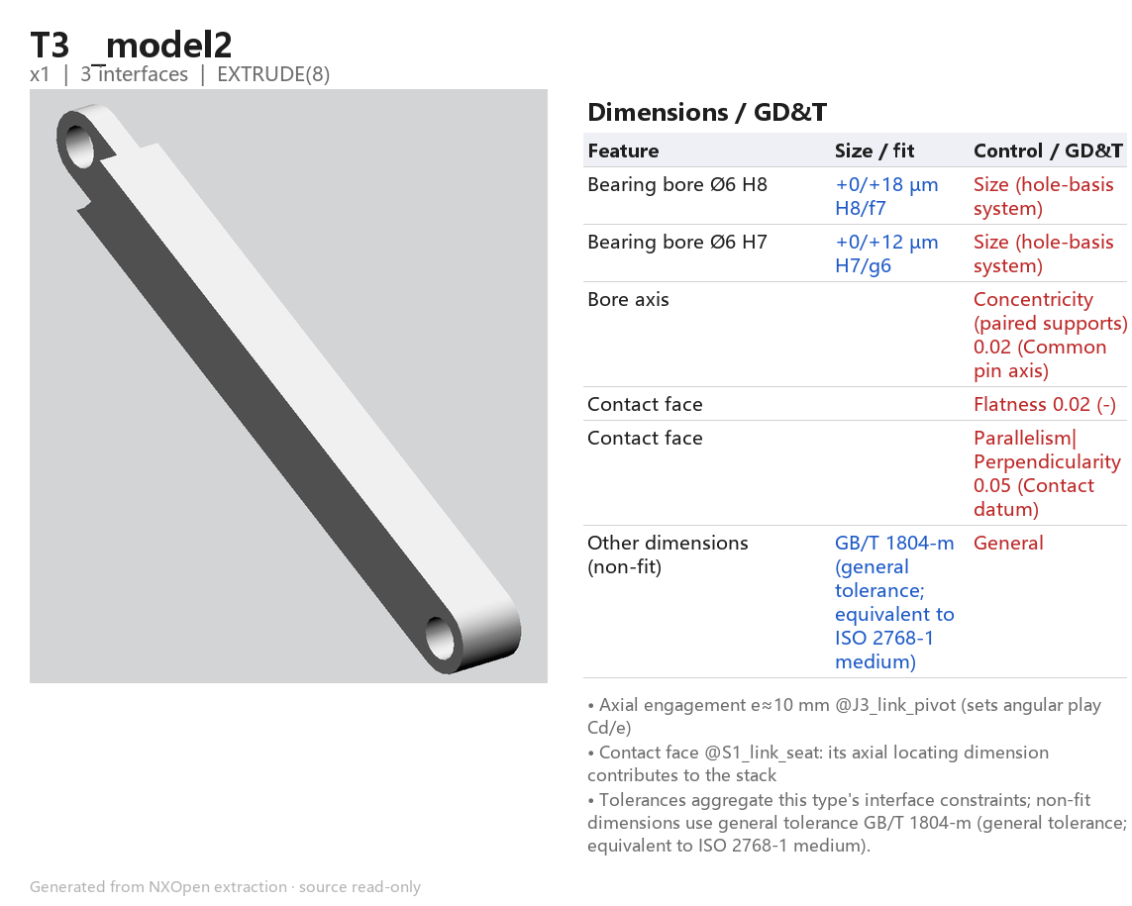
Figure 4-3 T3 Tolerance card
Feature | Size / fit | Control / GD&T | Source interface
Bearing bore Ø6 H8 | +0/+18 µm H8/f7 | Size (hole-basis system) | J2_slider
Bearing bore Ø6 H7 | +0/+12 µm H7/g6 | Size (hole-basis system) | J3_link_pivot
Bore axis |  | Concentricity (paired supports) 0.02 | J3_link_pivot
Contact face |  | Flatness 0.02 | S1_link_seat
Contact face |  | Parallelism|Perpendicularity 0.05 | S1_link_seat
Other non-fit dimensions: ISO 2768-1 class m.

4.4 T4 (EXTRUDE(14), ×2)
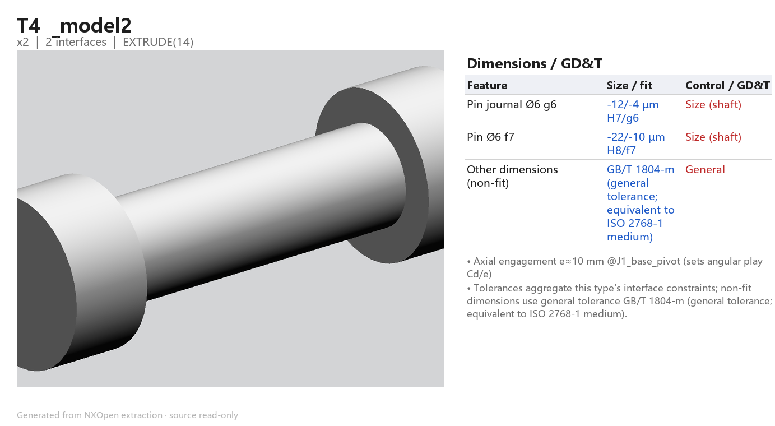
Figure 4-4 T4 Tolerance card
Feature | Size / fit | Control / GD&T | Source interface
Pin journal Ø6 g6 | -12/-4 µm H7/g6 | Size (shaft) | J1_base_pivot
Pin Ø6 f7 | -22/-10 µm H8/f7 | Size (shaft) | J2_slider
Other non-fit dimensions: ISO 2768-1 class m.

4.5 T5 (EXTRUDE(15:1B), ×2)
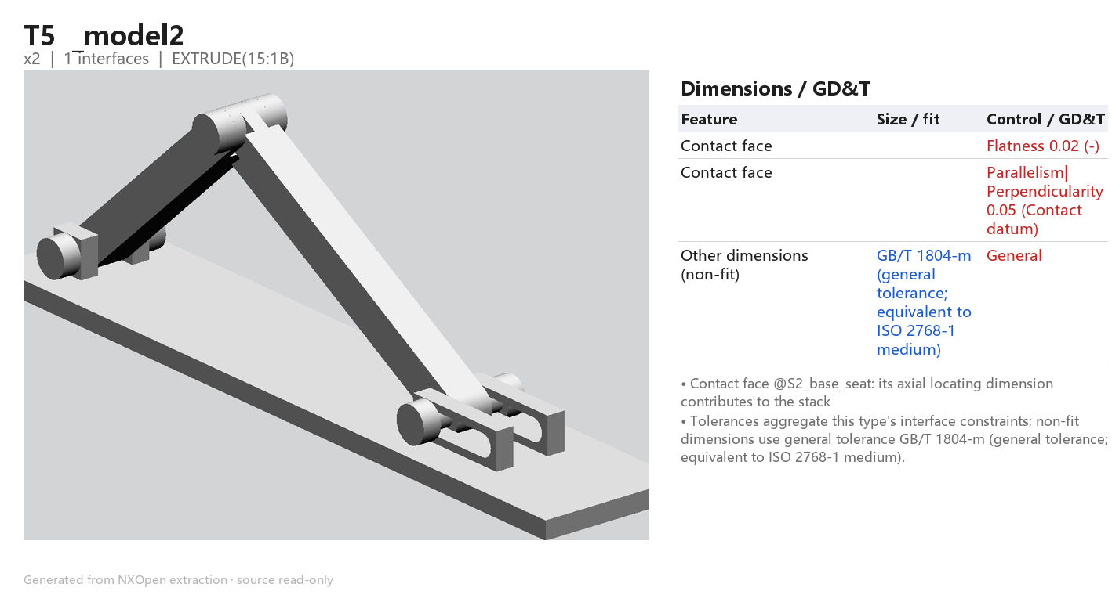
Figure 4-5 T5 Tolerance card
Feature | Size / fit | Control / GD&T | Source interface
Contact face |  | Flatness 0.02 | S2_base_seat
Contact face |  | Parallelism|Perpendicularity 0.05 | S2_base_seat
Other non-fit dimensions: ISO 2768-1 class m.

4.6 T6 (Pattern Geometry(19:1A), ×1)
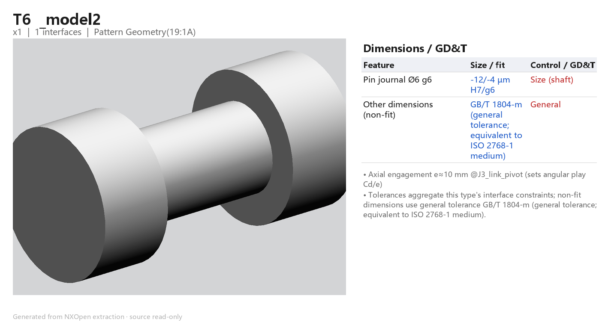
Figure 4-6 T6 Tolerance card
Feature | Size / fit | Control / GD&T | Source interface
Pin journal Ø6 g6 | -12/-4 µm H7/g6 | Size (shaft) | J3_link_pivot
Other non-fit dimensions: ISO 2768-1 class m.

5 Key characteristic (KC) verification
Symmetric toleranced PMI dimensions define the KCs; chains and sensitivities derive from measured geometry.
ID | Nominal | Specification | Verdict | Achievable WC | Achievable RSS | Recommendation
KC51 | 50.9902 | ±9.45 | OK | ±0.171 | ±0.111 | Meets specification
KC15 | 15 | ±0.10 | OK | ±0.047 | ±0.037 | Meets specification

5.1 KC51 (Link apex pin T6 to base edge (perpendicular distance))
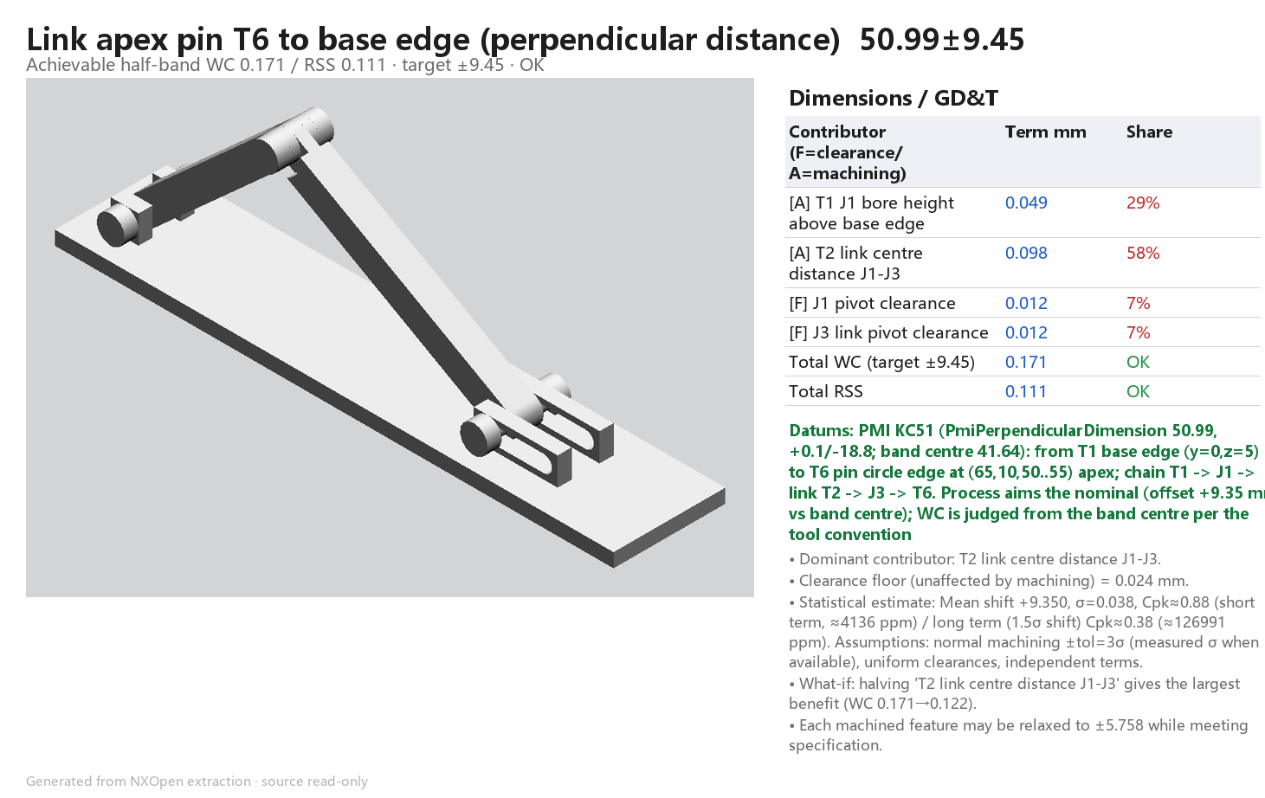
Figure 5-1-a KC51 Breakdown and verdict

5.2 KC15 (Base pivot X position (T1 end edge to pivot pin T4))
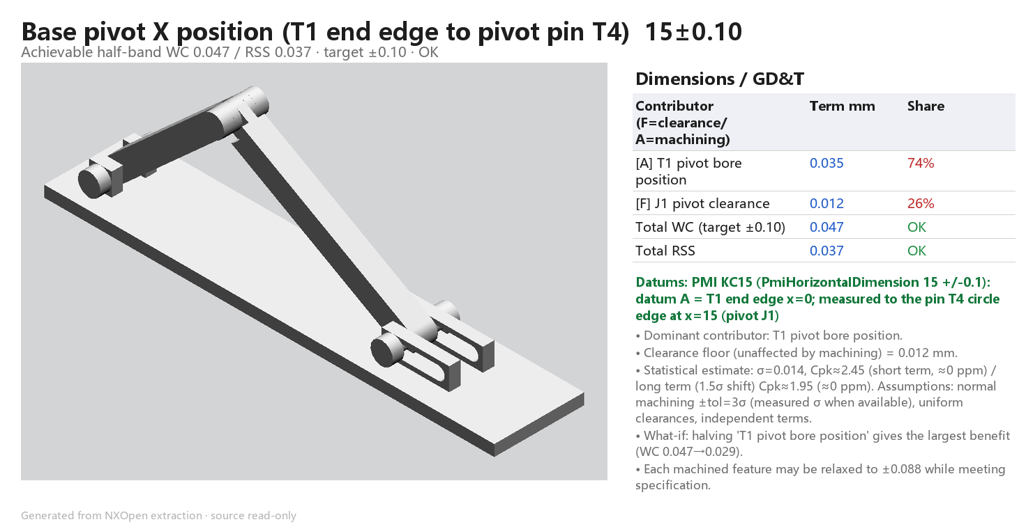
Figure 5-2-a KC15 Breakdown and verdict

6 Conclusions
• KC15 (15 +/-0.1, T1 end edge to pivot pin T4): worst-case 0.047 mm against +/-0.1 -> OK.
• KC51 (50.99, +0.1/-18.8, T1 base edge to apex pin T6): worst-case 0.171 mm against a +/-9.45 band half-width -> OK; the T2 link centre distance (ISO 2768-1 f, +/-0.15) dominates.
• All KCs are OK, so ISO-286 toleranced dimensions and GD&T frames were written back to _model2_toleranced.prt (source part untouched).
• Estimated machining cost about $233 USD per assembly (stated rate assumptions, not a shop quote).

7 Assumptions and traceability
• T1 J1 bore height above the base edge (10 - 5 = 5 mm) is an un-toleranced dimension: ISO 2768-1 class f, +/-0.05 mm.
• KC15 bore position is held to ISO 286 IT10 (+/-0.035 mm) - an allocation chosen so that bore position plus the H7/g6 clearance stays inside +/-0.1.
• KC51 PMI band is asymmetric (+0.1/-18.8); the process is assumed to aim the band centre for the worst-case verdict, while the statistical block reports the +9.35 mm offset when aiming the nominal.
• Body T5 is an open sheet body (retainer); its NX volume is invalid, so a D10 x 5 mm cylinder envelope was used for cost only.
• Cost: 6061 aluminium for plate, links, retainers; 1045 steel for pins; $4.0 per machining index unit, $4.5/kg and $1.6/kg stock - assumptions, not quotes.
• J2 slot travel taken as 20 mm from the slot centre-to-centre spacing (x=145 to x=165).
• All tolerance values come from gb_tolerance.py (verified ISO 286 / ISO 2768-1 tables) or measured NX expressions/geometry.
• General tolerance fallback: ISO 2768-1 class m.
• The source .prt remained read-only; it was neither modified nor saved.

8 Deliverables
Deliverable contract verification: COMPLETE
The final run manifest verified 6 part types and 2 key characteristics. All required artifacts below were present at completion.
Phase | Artifact | Status
1 Measure | assembly.json | Verified
1 Measure | facts.json | Verified
1 Measure | features.json | Verified
1 Measure | pmi.json | Verified
2 Classify | interfaces.json | Verified
3 Tolerance | part_tol.json | Verified
3 Tolerance | cards/card.INDEX.png | Verified
3 Tolerance | cards/card.T1.png | Verified
3 Tolerance | cards/card.T2.png | Verified
3 Tolerance | cards/card.T3.png | Verified
3 Tolerance | cards/card.T4.png | Verified
3 Tolerance | cards/card.T5.png | Verified
3 Tolerance | cards/card.T6.png | Verified
4 KC verification | cards/card.KC51.verdict.png | Verified
4 KC verification | cards/card.KC51.status.json | Verified
4 KC verification | cards/card.KC15.verdict.png | Verified
4 KC verification | cards/card.KC15.status.json | Verified
5 Report | report_model2.md | Verified
6 Word | report_model2.docx | Verified
7 PMI write-back | _model2_toleranced.prt | Verified
7 PMI write-back | annotate_report.json | Verified
9 Cost | cards/card.COST.png | Verified
9 Cost | cards/cost_card.status.json | Verified

